VIVA Header - MOSFET

# Overview

A VIVA Header that allows a MOSFET to be experimented with as a variable resistor.

The gate of the MOSFET is provided a voltage controlled by the PWM duty cycle. When the duty cycle is 100%, this voltage is Vdd. When the duty cycle is 0%, this voltage is Vss.

The MOSFET drain current can be found by subtracting the ADC values of AN2 and AN1.

The microcontroller can characterize the MOSFET’s operation by sweeping the PWM duty cycle, and sampling AN1 and AN2.

# Layout Screenshot

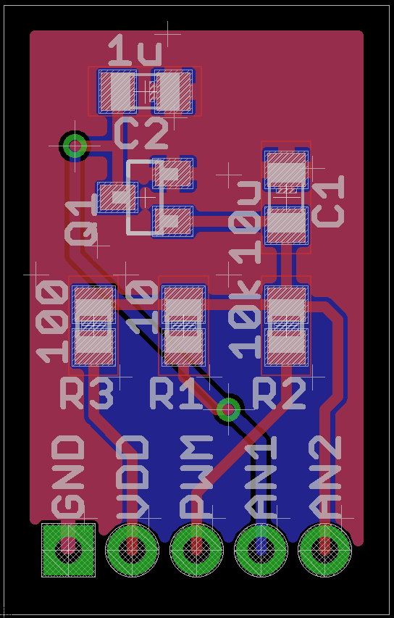

# Schematic

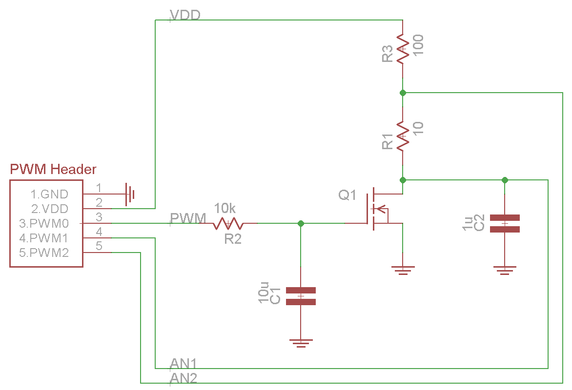

# Notes